WE DON’T DO THIS ANY MORE. We use DBConvert. See DetailDesign2.docx

12/07/2014

# Details of Communication between Access and MySQL

TO copy data FROM MySQL TO Access, Link from Access to MySQL. Periodically, you can refresh (copy) the data from MySQL to Access.

In Access, click External Data, ODBC Databases, and select Link

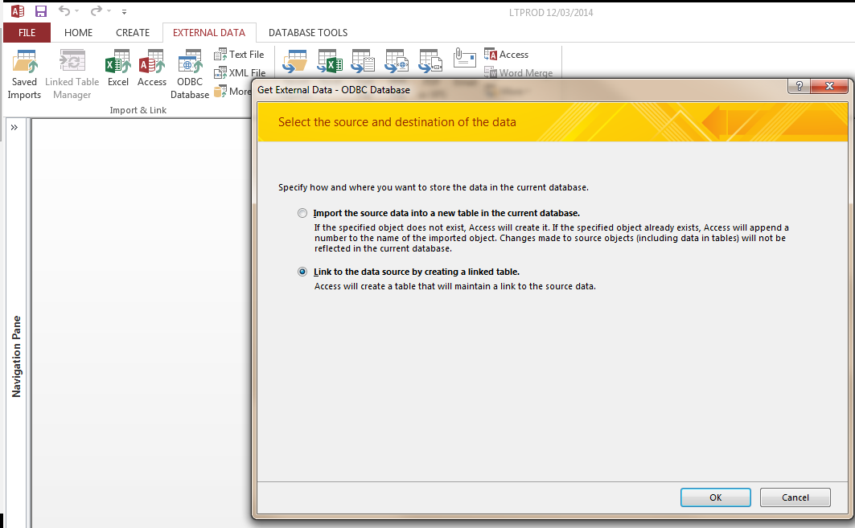

Select the ODBC database that has been set up for the local MySQL database (see details in a separate section, below)

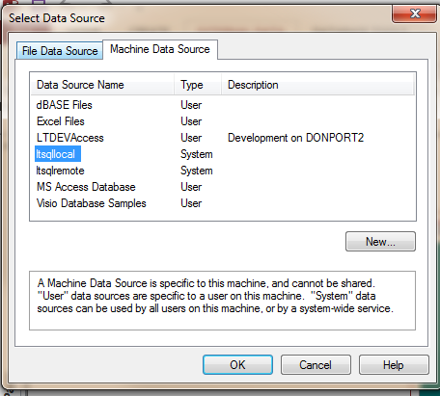Dd

Select the tables you want to link.

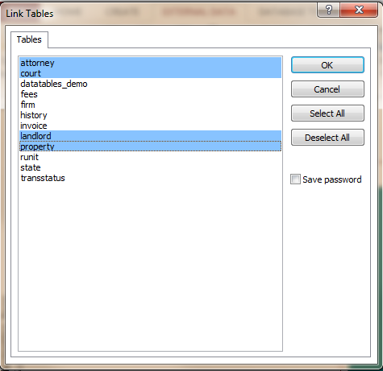Dd

They show up as linked tables in access.

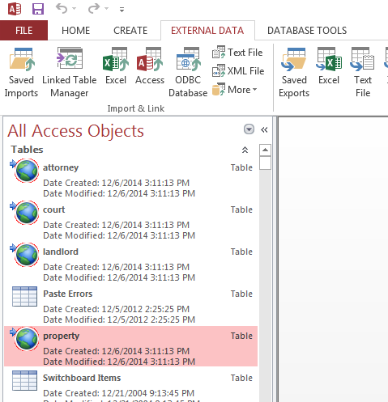

Then to copy the data to Access, double click Linked Table Manager, check the Linked Tables you want to update, and Click OK.

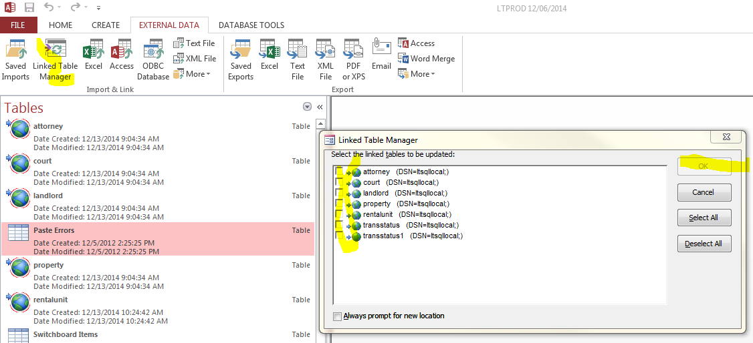

# Getting New Data from Access to MySQL

To compare tables copied from MySQL to Access, with native tables in Access, write queries like

SELECT * FROM tbl_landlord WHERE landlordid NOT IN (SELECT landlordid FROM landlord)

Note that the “tbl_” tables are those in Access.

The above query finds records in Access, that are not in MySQL. THIS IS NOT the usual way the system will be operated, after it is set up.

To copy those “new” records from Access to MySQL, save the query above in Access, then reopen it.

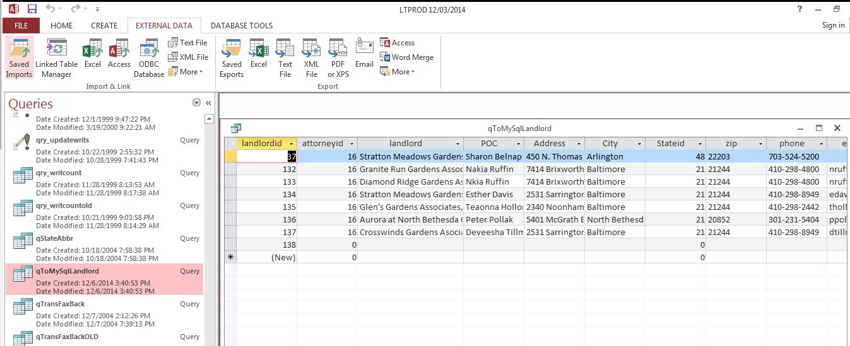

While the query above is in the Access window, under the “More” tab,

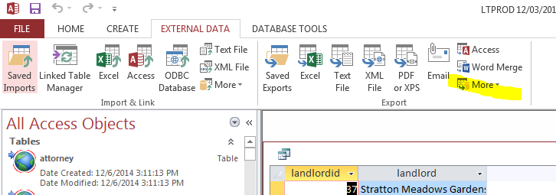

Pick “Export to ODBC data source, pick ltlocal, and save the Export as something like ExportExtraLandlords.

This results in a MySQL table as below

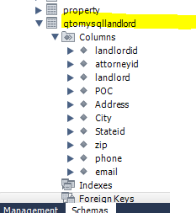Ddd

Then, in MySQL, to get these columns added to the Landlord table, write a query like the following. Note some values are repeated in the second select statement, to ensure that pointers line up between Access and MySQL.

insert into landlord

(`landlordid`,

`attorneyid`,

`landlord`,

`POC`,

`Address`,

`City`,

`Stateid`,

`zip`,

`phone`,

`email`,

`idsqllandlord`,

`LastUpdateDt`,

`LastUpdateBy`,

`Deleted`,

`idsqlattorney`,

`idsqlstate`)

select landlordid,

attorneyid,

landlord,

POC,

Address,

City,

Stateid,

zip,

phone,

email,

landlordid,

Now(),

'don',

0,

attorneyid,

stateid

from qtomysqllandlord;

Here is Property cleanup:

delete from qtomysqlproperty where COALESCE(landlordid, 0) = 0

insert into property (

propid,

landlordid,

attorneyid,

courtid,

Complex,

prop_alias,

Address1,

Address2,

Address3,

Address4,

city,

stateid,

zip,

SuitFee,

WritFee,

OtherFee,

vaLateFee,

vaLatePercent,

CourierFee,

absolutefee,

judgmentfee,

credit,

legalfee,

flatfee,

standalone,

nixabs,

ispec1,

addlate,

addlegal,

lladdr,

sortorder,

enviraffect,

reqfuture,

useunitcity,

license,

LastUpdateDt,

LastUpdateBy,

Deleted,

idsqlproperty,

idsqllandlord,

idsqlattorney,

idsqlcourt,

idsqlfirm,

idsqlstate

)

SELECT

propid,

landlordid,

attorneyid,

courtid,

Complex,

prop_alias,

Address1,

Address2,

Address3,

Address4,

city,

stateid,

zip,

SuitFee,

WritFee,

OtherFee,

vaLateFee,

vaLatePercent,

CourierFee,

absolutefee,

judgmentfee,

credit,

legalfee,

flatfee,

standalone,

nixabs,

ispec1,

addlate,

addlegal,

lladdr,

sortorder,

enviraffect,

reqfuture,

useunitcity,

license,

Now(),

'don',

0,

propid,

landlordid,

attorneyid,

courtid,

1,

stateid

FROM lt.qtomysqlproperty;

# Details on ODBC Connections

Local

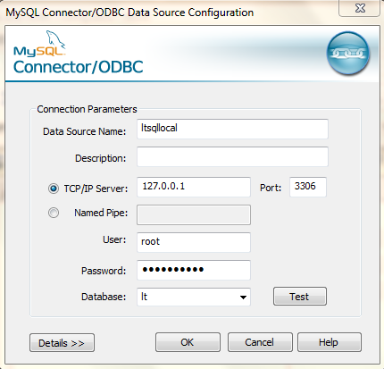

this is testlocal.cfm

<cfquery name="world" datasource="ltlocal">

select * from msql_history limit 3

</cfquery>

<cfdump var="#world#">

Remote

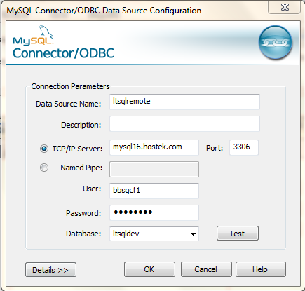

this is testremote.cfm

<cfquery name="world" datasource="ltsqldev">

select * from state

</cfquery>

<cfdump var="#world#">